**TASK 5 - MAVEN**

NAME:**TAMILARASI P**

ROLL NUMBER: **22CSR220**

STEP-1:

Create new folder and install maven

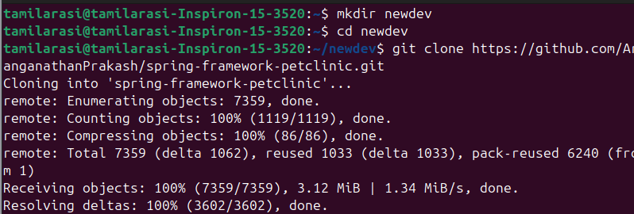

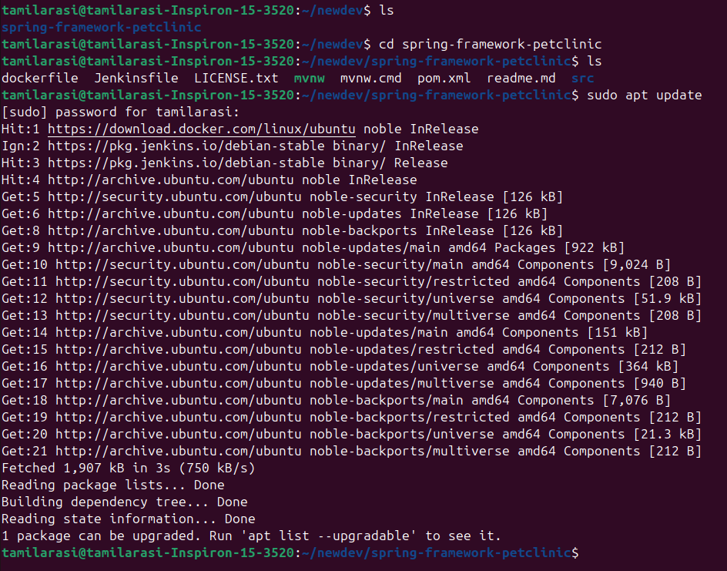

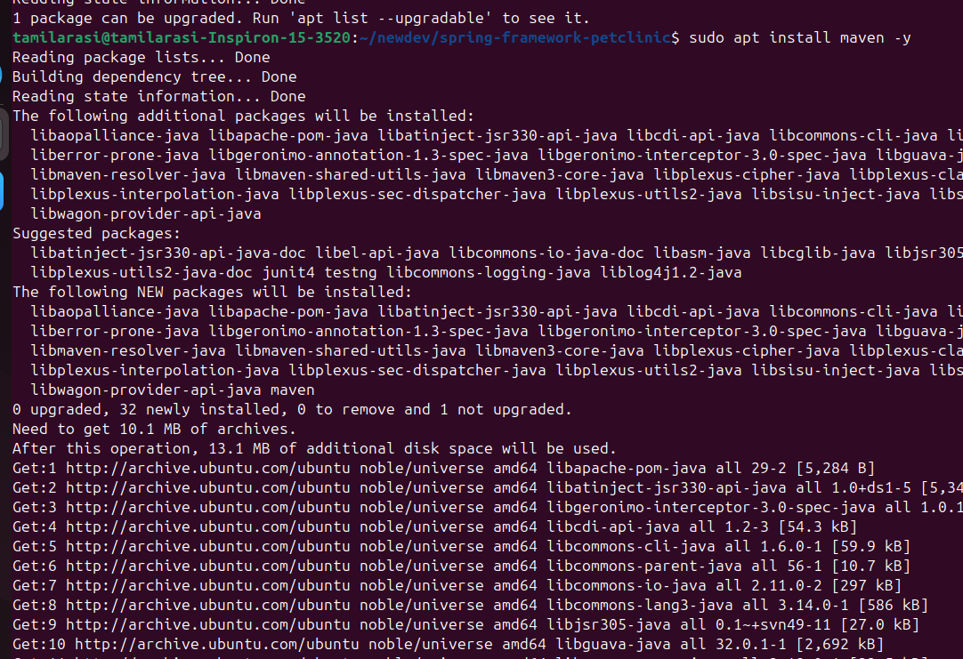

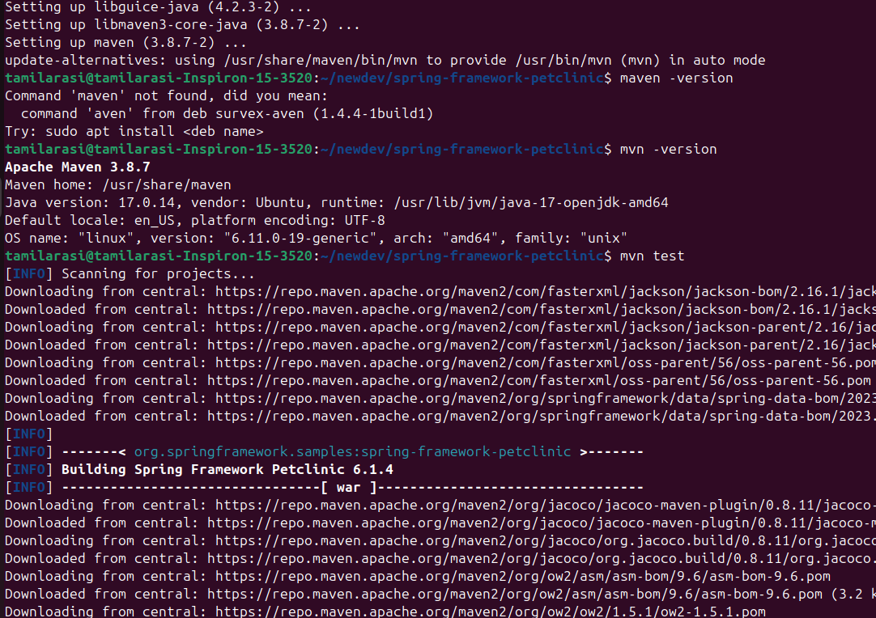

STEP-2: mvn clean

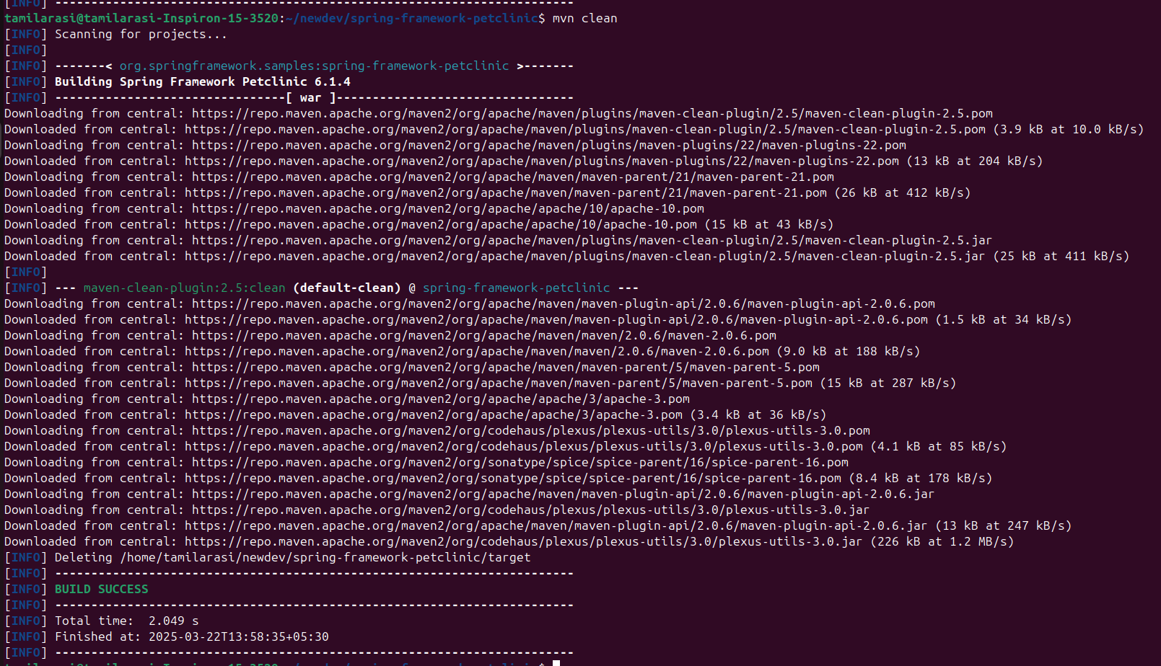

STEP-3: mvn install

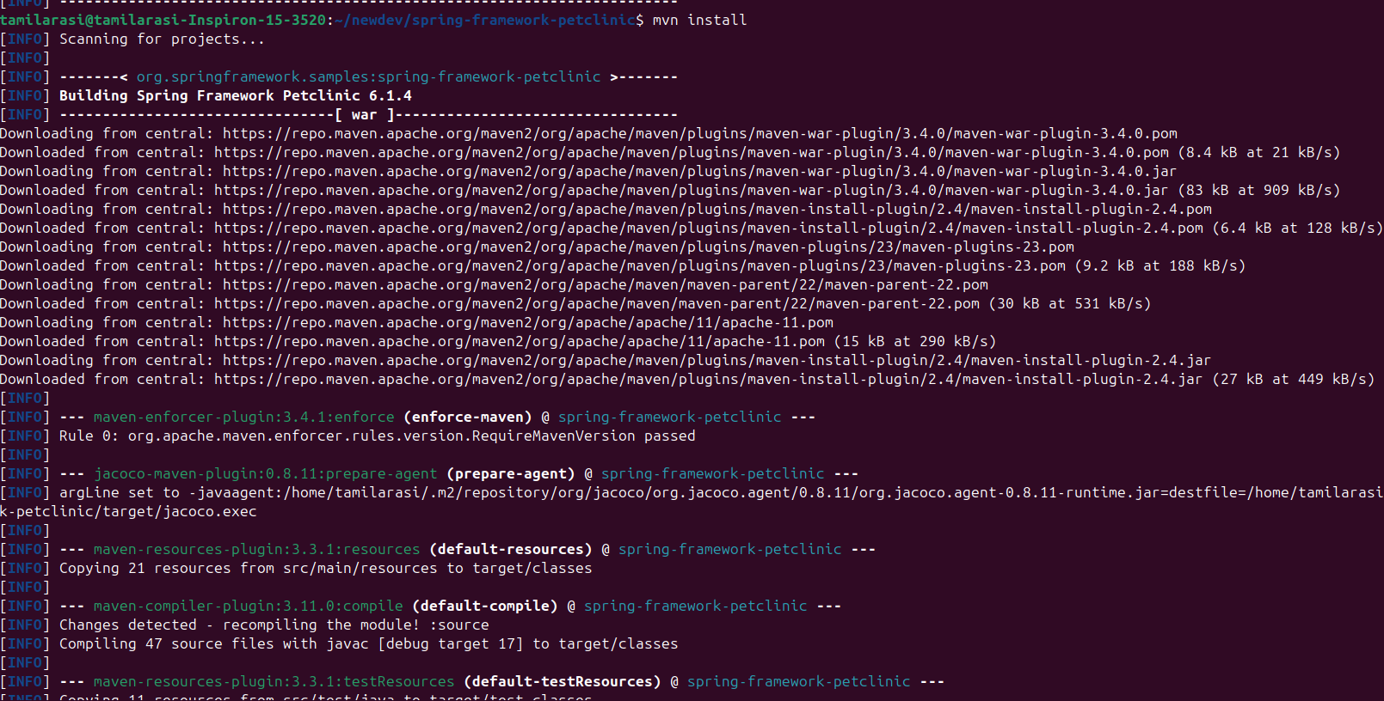

STEP-4: mvn package

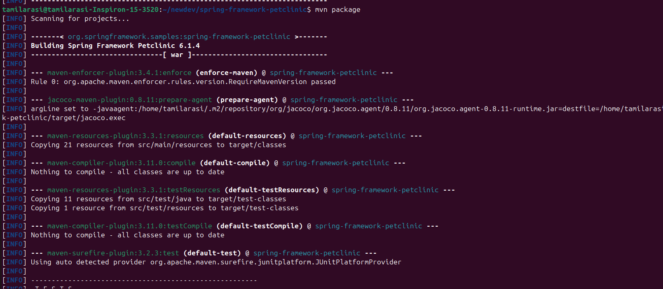

STEP-5: Go to target folder and check whether it has petclinic.war file

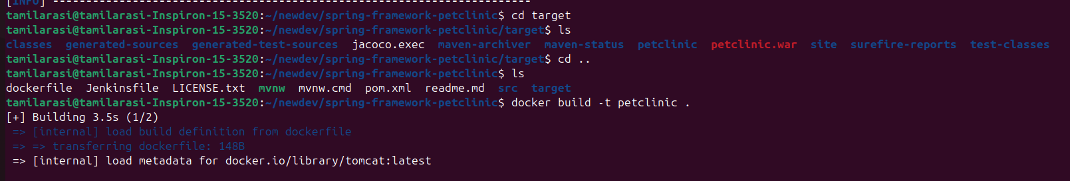

STEP-6: Install Docker and login in it and push the image  
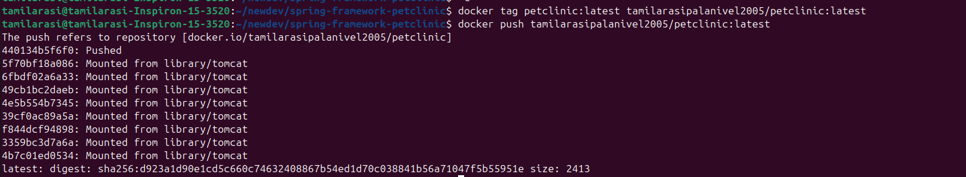

STEP-7: Check Docker images

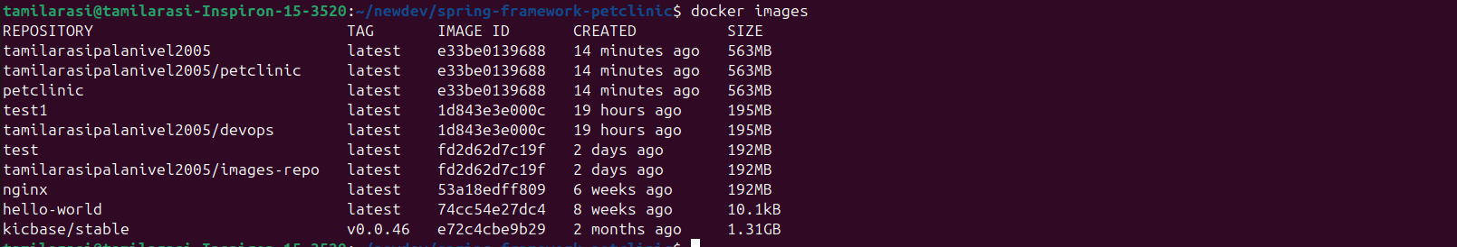

STEP-8: Run Minikube

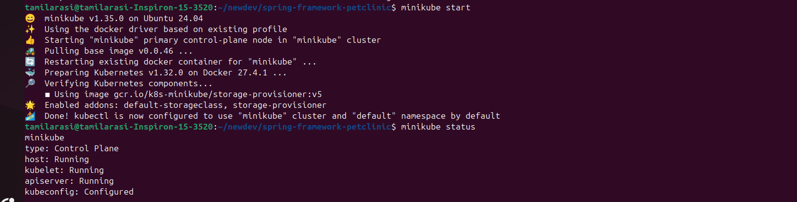

STEP-9: Create kubectl  
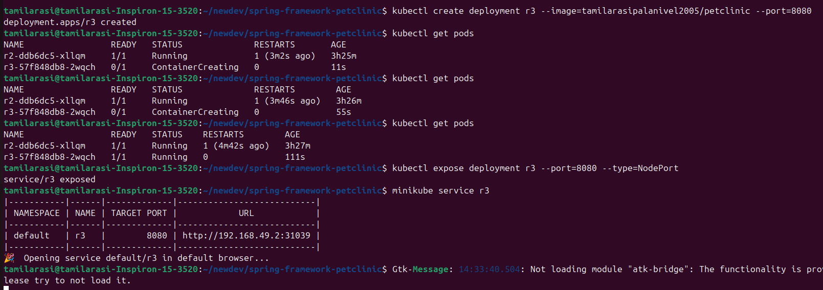

STEP-10: Output in Browser

